29 September 2020
PRESS RELEASE

ICARS and the Government of Georgia commit to fighting resistance to antibiotics together
The Danish-founded organization will work with two Georgian ministries to establish Antimicrobial Stewardship in healthcare facilities and agricultural and veterinary settings in Georgia

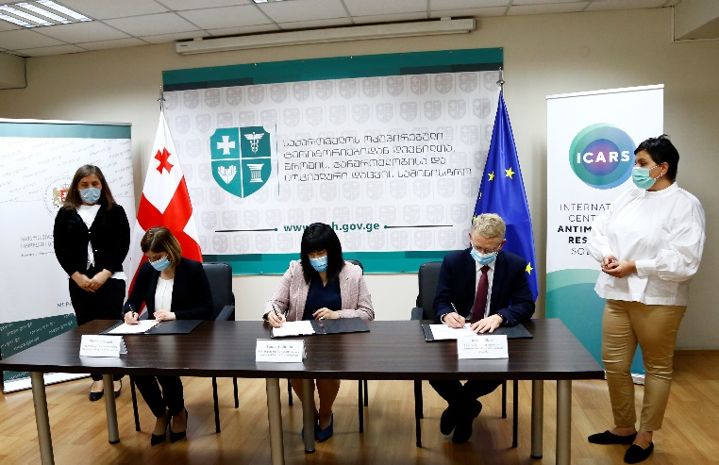
29 SEPTEMBER 2020, COPENHAGEN – Today, the International Centre for Antimicrobial Resistance Solutions (ICARS) signed a Memorandum of Understanding with Georgia. The partnership with two Georgian ministries will result in stewardship programmes for fighting antimicrobial resistance in Georgia. The partners will co-develop demonstration projects, working with hospital administrations, healthcare professionals, veterinarians and local farmers to create and implement a set of standards for the use of antibiotics in human medicine and agriculture.

The Georgian signatory-ministries are: the Ministry of Environmental Protection and Agriculture of Georgia (MEPA) and the Ministry of Internally Displaced Persons from the Occupied Territories, Labour, Health and Social Affairs of Georgia (MoIDPLHSA).

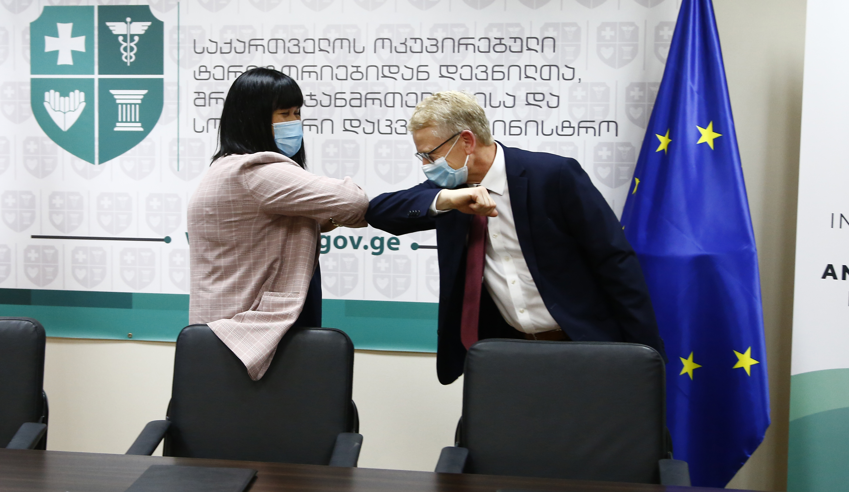“We are excited to see commitment from the Georgian government to fight antibiotic resistance and look forward to working together on developing practical solutions” said Robert Skov, MD and Scientific Director of ICARS.

Antimicrobial resistance (AMR) is a global issue that knows no borders. The lack of sustained action aggravates AMR, leading to 700.000 deaths every year worldwide, a number which will continue to rise if appropriate action is not taken. Low- and middle income countries are especially challenged in moving their national policies on AMR into practice. Through the collaboration with ICARS, Georgia takes a concrete step forward towards lowering AMR and stopping superbugs. Georgia is the second country partnering with ICARS, after Vietnam committed to collaborate with the organization on two implementation projects.

“The memorandum envisages the implementation of activities against antimicrobial resistance. The process of using antimicrobial drugs becomes even more active in pandemic conditions. Today we have the opportunity to join the international movement and further develop this cooperation to minimize the risks of antimicrobial resistance," said Tamar Gabunia, First Deputy Minister of IDPs, Labour, Health and Social Affairs of Georgia, at the Signing Ceremony.

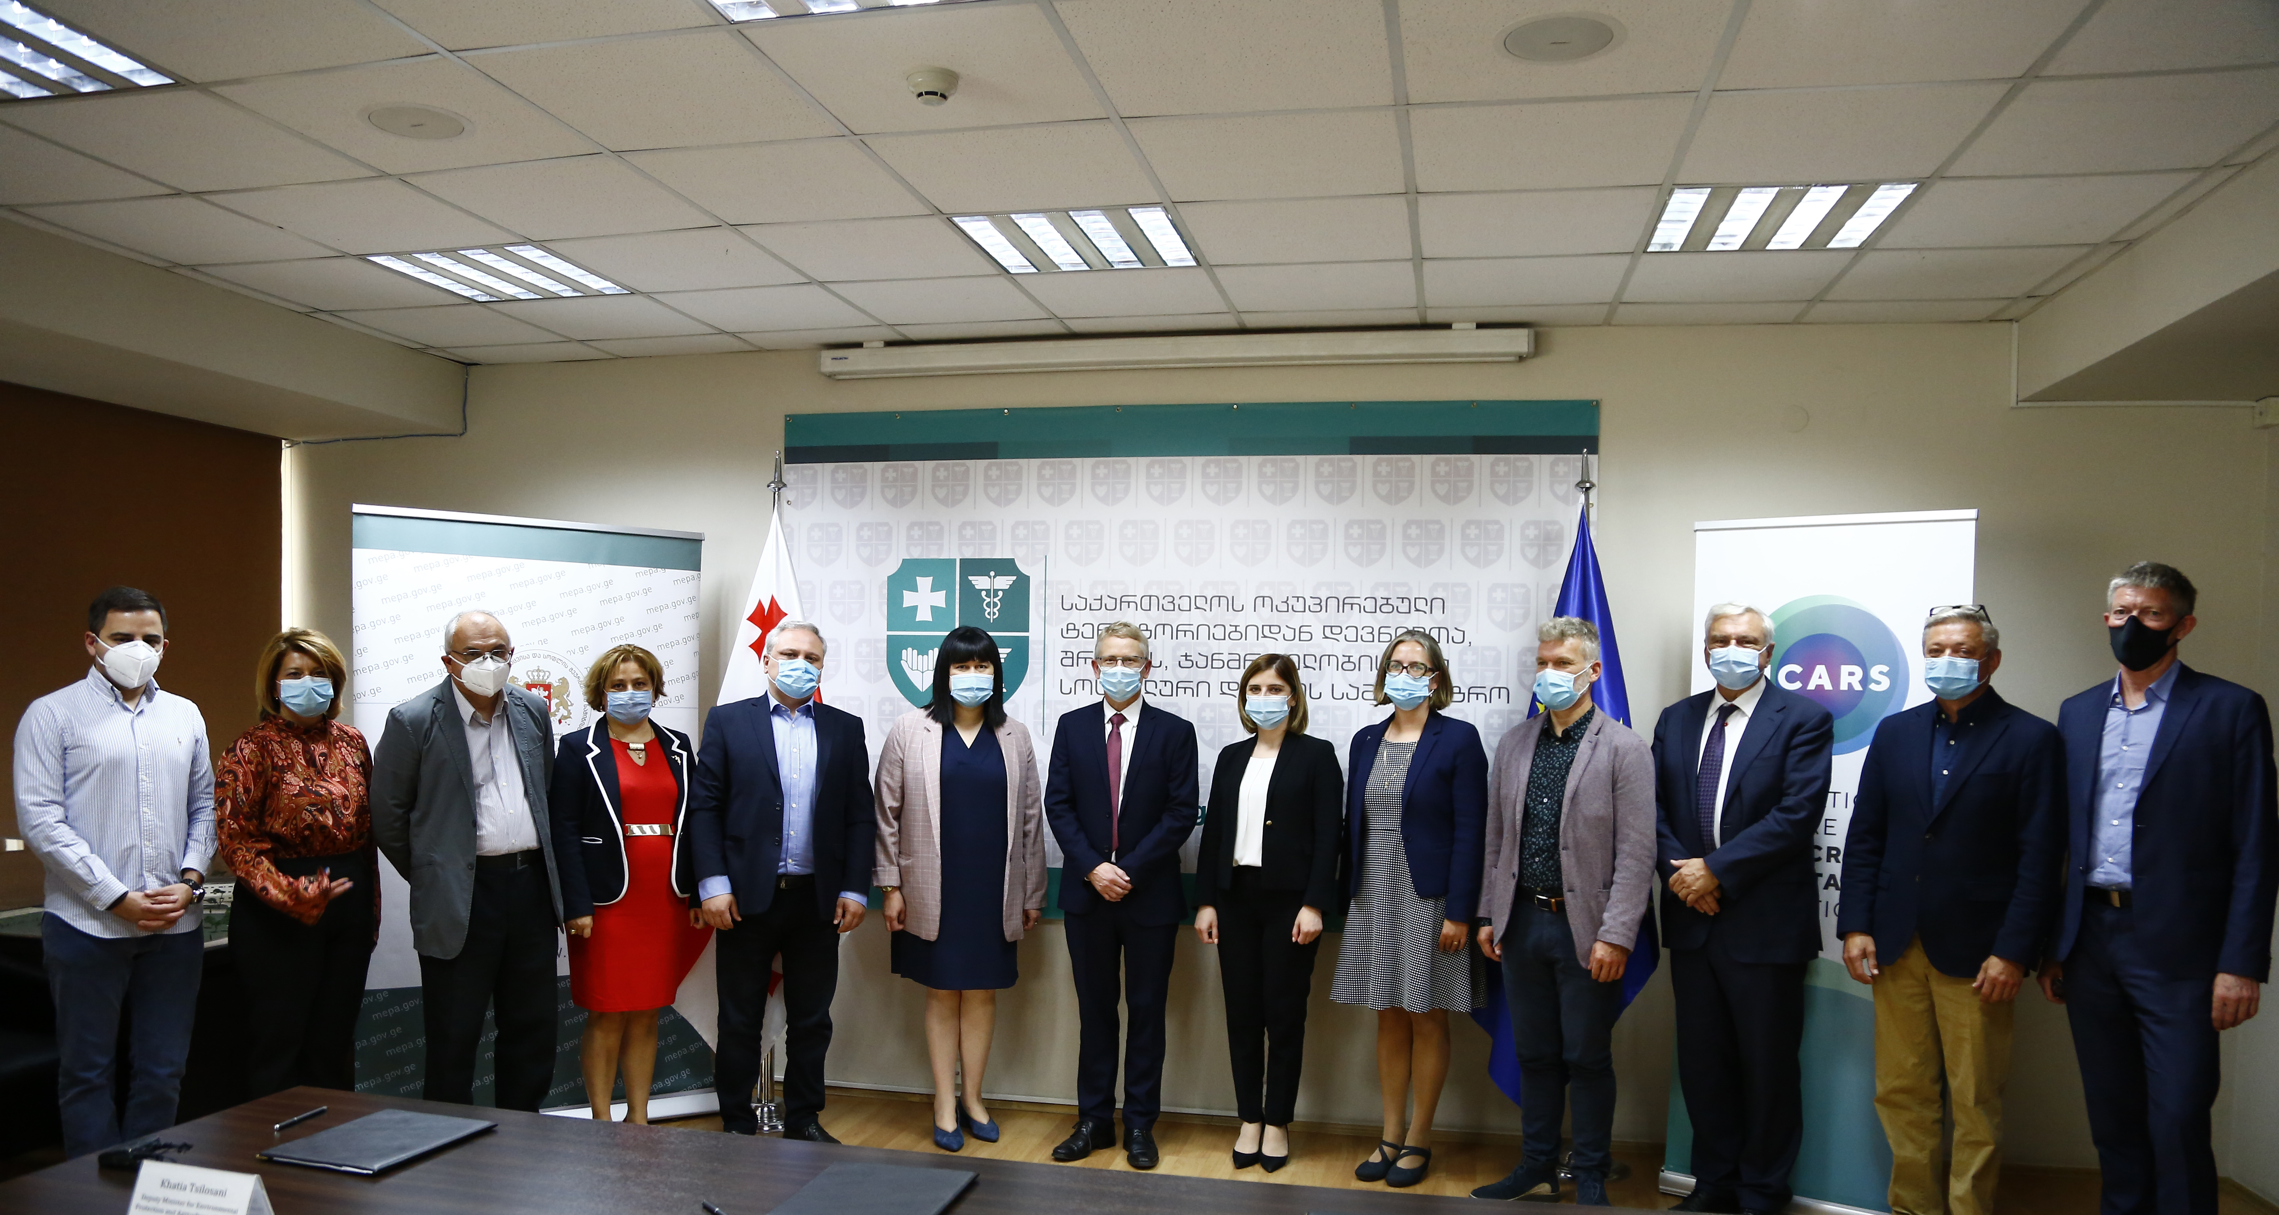

Photos:
Photo 1 – Seated, left: Khatia Tsilosani, Deputy Minister for Environmental Protection and Agriculture of Georgia; middle: Tamar Gabunia, First Deputy Minister of IDPs, Labour, Health and Social Affairs of Georgia; right: Robert Leo Skov, MD, Scientific Director of ICARS
Photo 2 – Left: Tamar Gabunia, First Deputy Minister of IDPs, Labour, Health and Social Affairs of Georgia; right: Robert Leo Skov, MD, Scientific Director of ICARS

About ICARS
ICARS conducts independent, policy-relevant, applied research at international, national and local levels in low- and middle income countries to identify evidence-based solutions for fighting resistance to antimicrobials. It works in close collaboration with governments, research communities and key stakeholders to create context-specific interventions and test solutions for lowering resistance to antibiotics. ICARS was born at the initiative of the World Bank and the Danish Government and is based in Copenhagen. ICARS is in the process of developing into an independent international institution and is seeking partners to fulfill its mission.

Media Contact
Georgiana Baciu
Communications Officer, ICARS
gsb@icars-global.org
+4523499851

